### How to Deposit and Withdraw on MoonSwap

In this article, I will show you how to **Deposit and Withdraw on MoonSwap**

1. Click your authorized Conflux wallet address

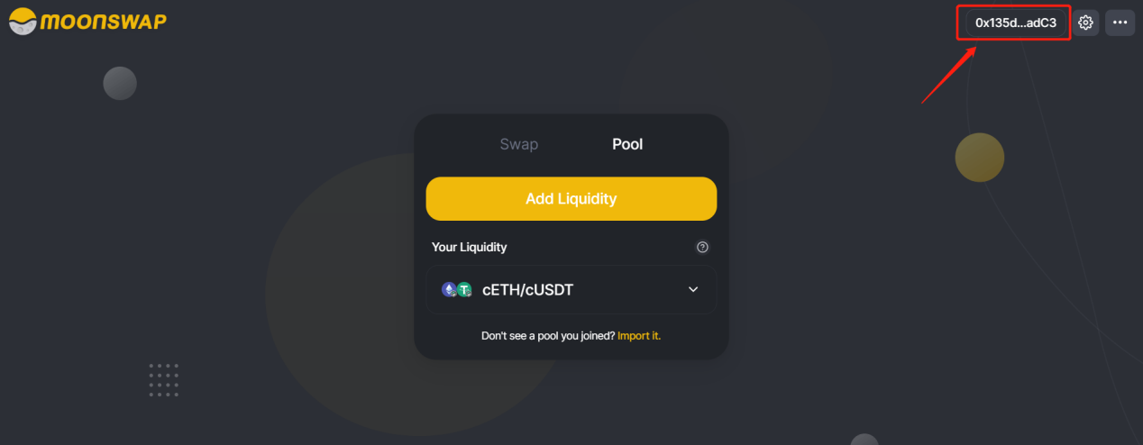

2. Click Wallet

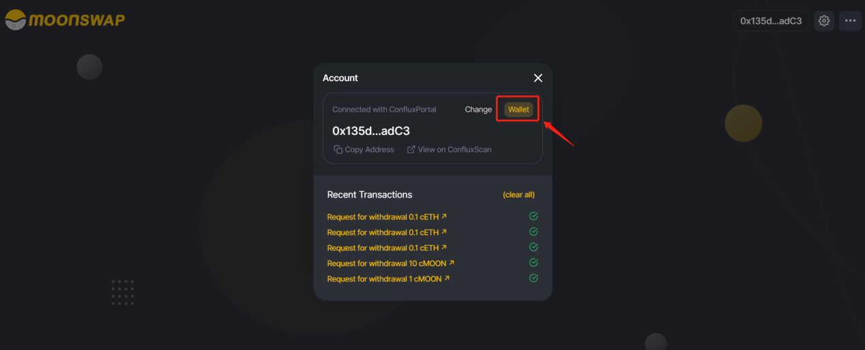

3. Click “Deposit”

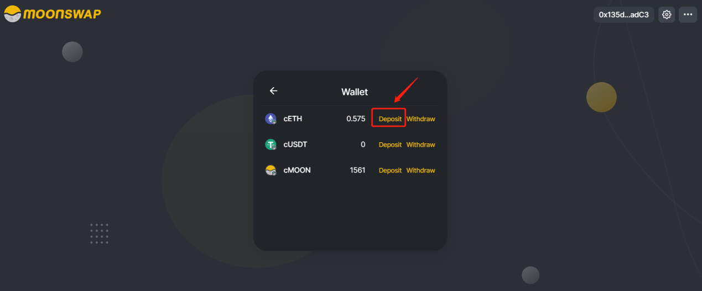

4. Copy the address shown below (you cannot deposit any non-ERC20 assets to this address, otherwise it may cause loss) . Also please read the deposit instructions carefully.

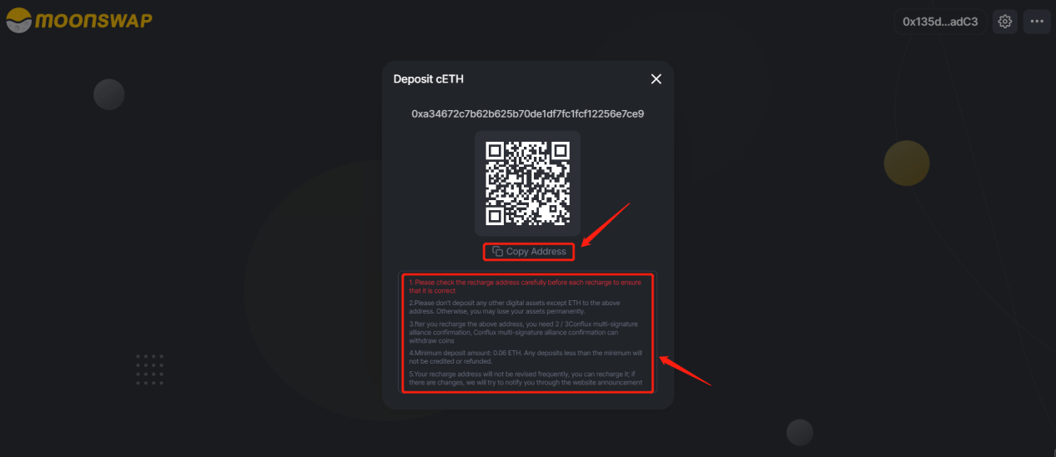

5. Click Ethereum Wallet and fill in the address you copied in the previous step, then enter the amount to be deposited and click Next, and finally click Confirm to complete the deposit. Because it is a cross-chain deposit, so it may cost 3~5 mins.

**It should be noted that you must NOT deposit ERC-20 assets to the Conflux wallet address, because that will cause your assets to be lost.**

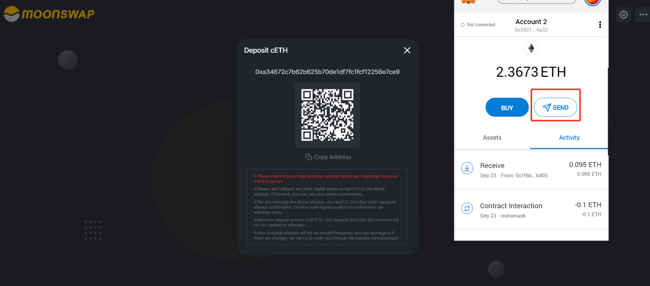

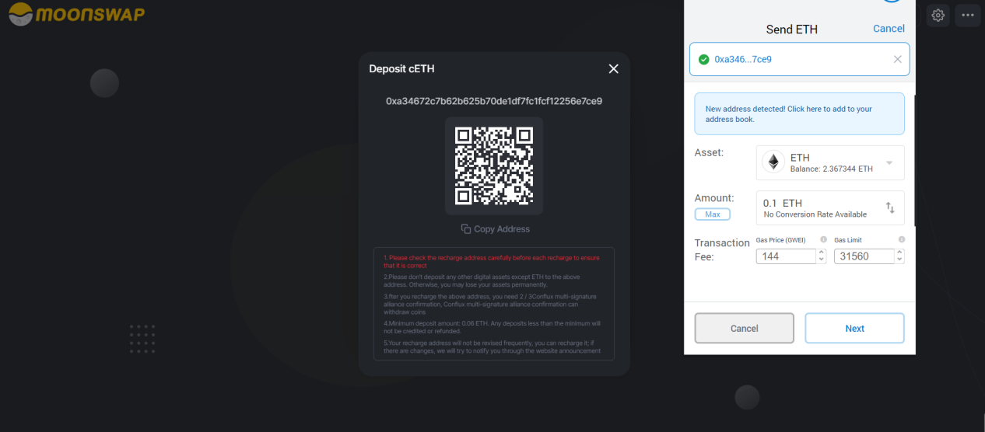

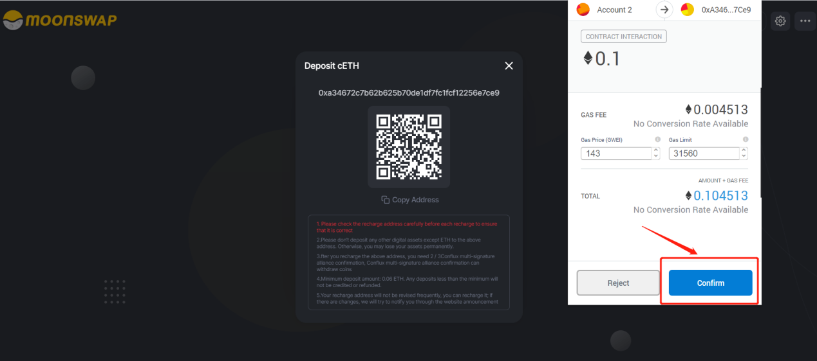

6. Next, let’s experience the withdrawal process, click “Withdraw”

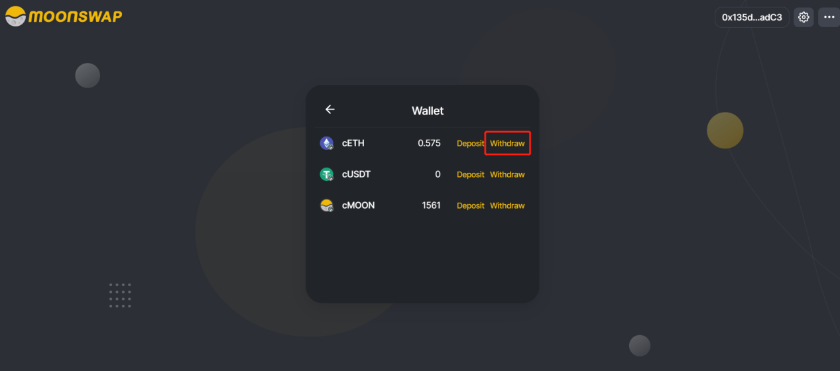

7. First enter the number of assets you want to withdraw, and then enter the Ethereum wallet address you want to withdraw (please DON’T withdraw assets to any address other than the Ethereum address)

You need to know that there is a small withdrawal fee for each withdrawal, please be prepared before withdrawing.

Please read the instructions for withdrawing assets carefully. After completing the preparations, please click Confirm Withdraw to withdraw assets.

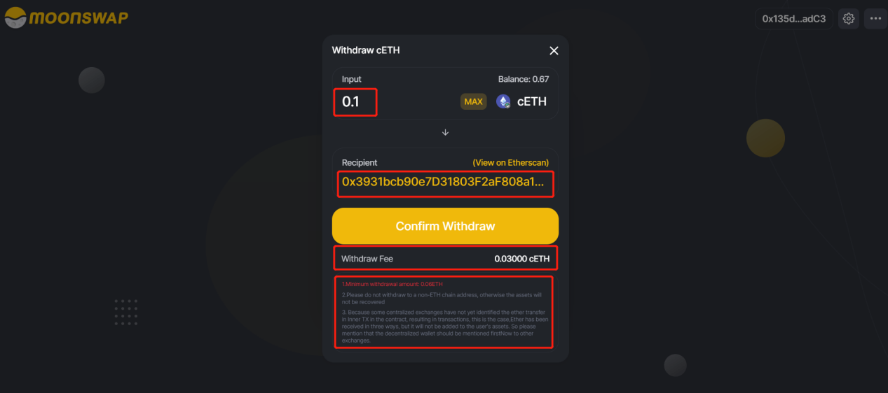

8. After clicking Confirm Withdraw, the Conflux wallet will be authorized at this time. Click Confirm to complete the withdrawal. This is a cross-chain withdrawal, which will arrive in about 5 minutes.

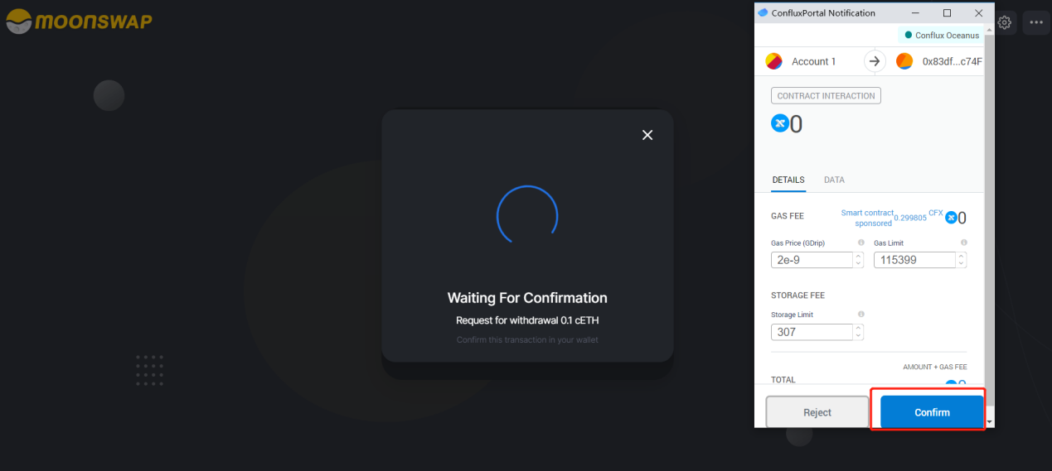

**9. Tips**

**You need to pay attention, please do not deposit any ERC20 assets (including MOON) to the Conflux wallet address because this will cause your assets to be lost.**

